# Comprehensive Assessment : Deep Learning - Predicting Diabetes Progression using Artificial Neural Networks

**Objective:**

You are required to model the progression of diabetes using the available independent variables. This model will help healthcare professionals understand how different factors influence the progression of diabetes and potentially aid in designing better treatment plans and preventive measures. The model will provide insights into the dynamics of diabetes progression in patients.

**Dataset:**

Use the Diabetes dataset available in the sklearn library.

**Key components to be fulfilled :**

**1.Loading and Preprocessing (4 marks)**

* Load the Diabetes dataset from sklearn.
* Handle any missing values if present.
* Normalize the features to ensure better performance of the ANN model.

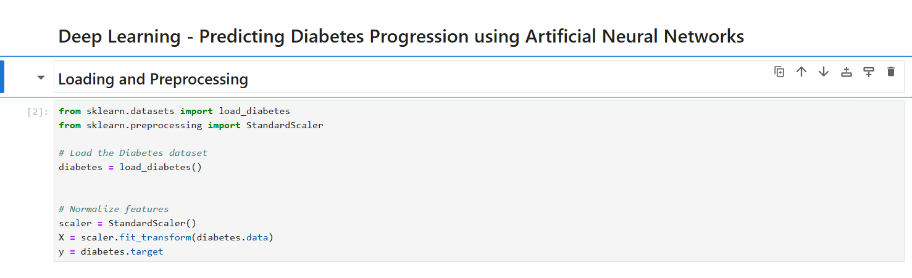

**2.Exploratory Data Analysis (EDA) (4 marks)**

* Perform EDA to understand the distribution of features and the target variable.
* Visualize the relationships between features and the target variable.

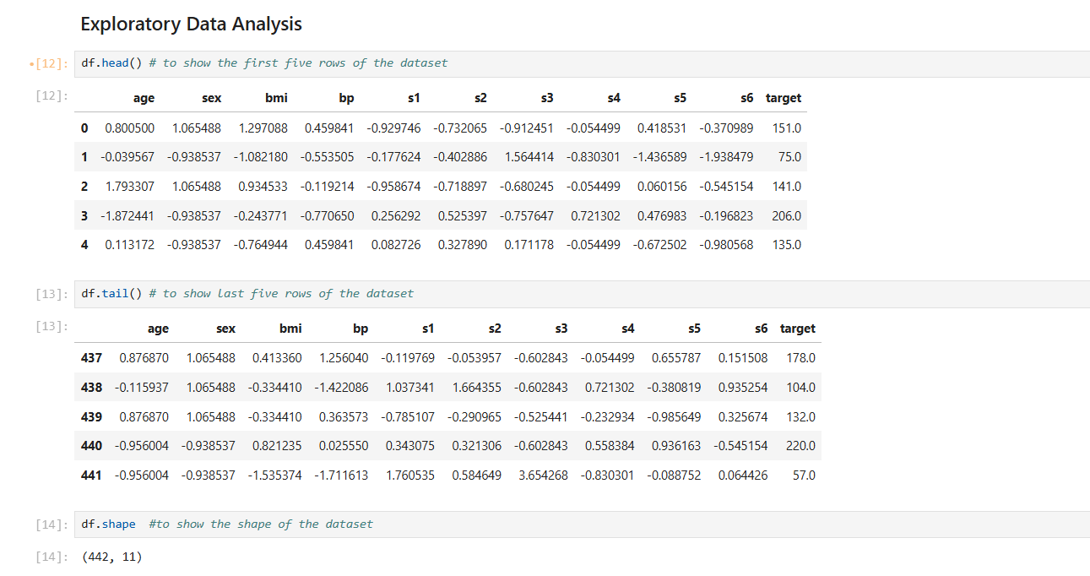

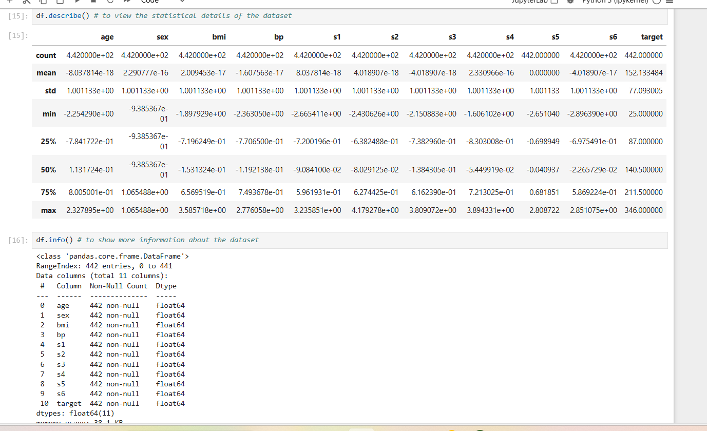

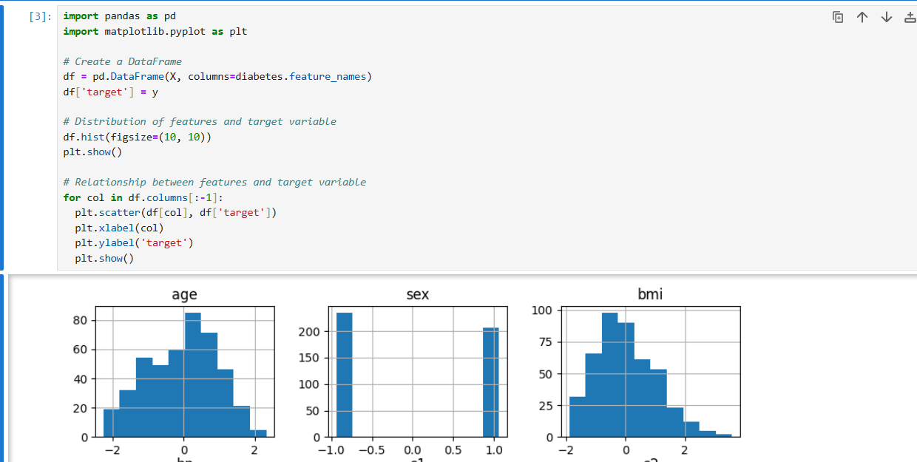

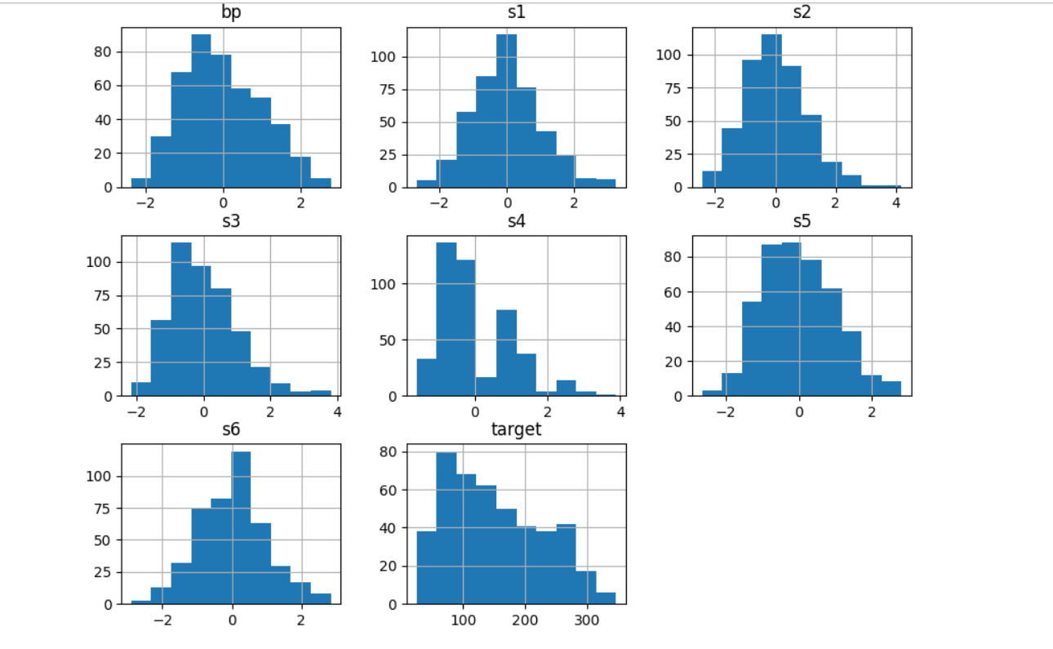

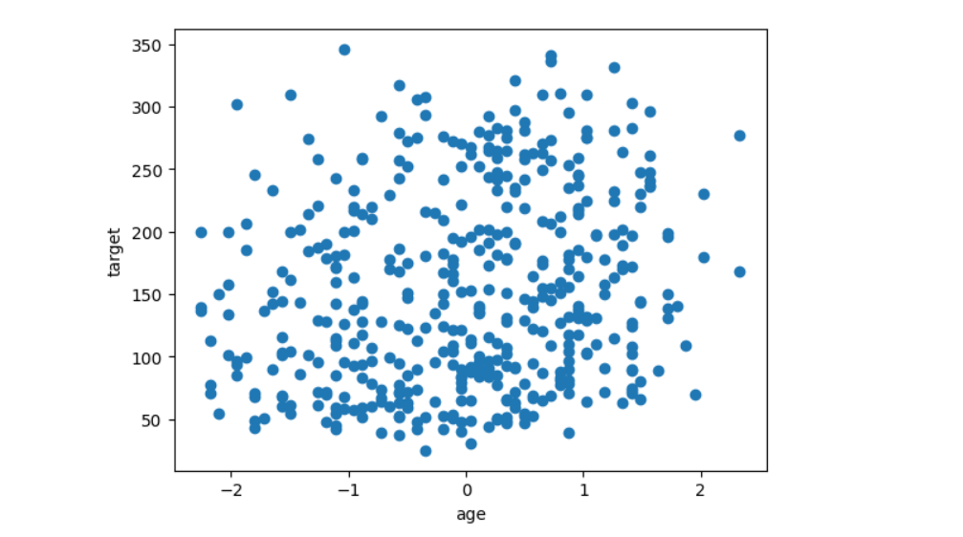

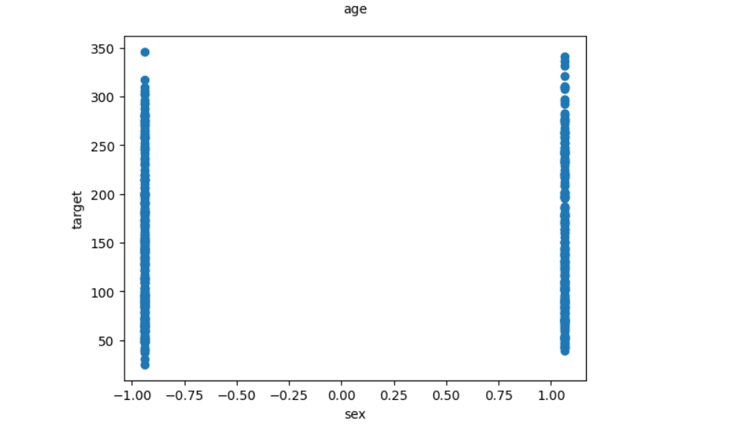

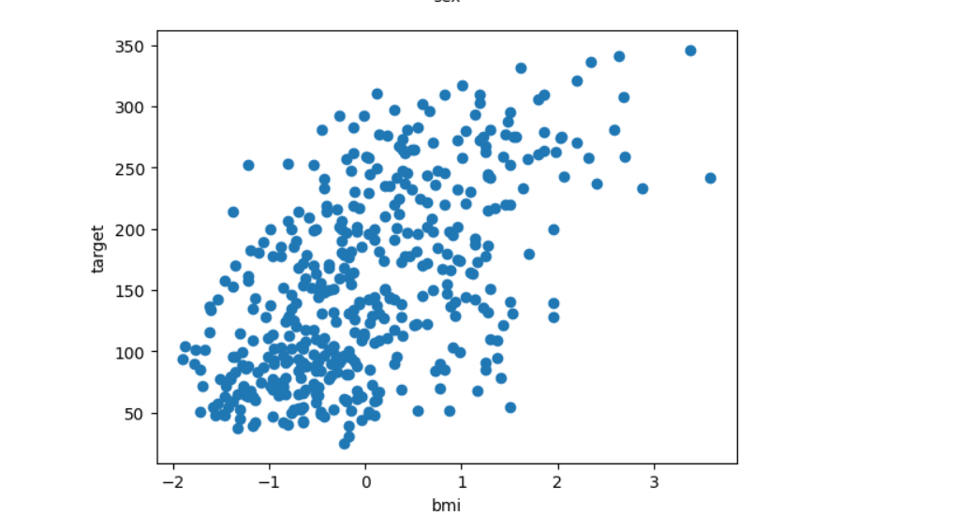

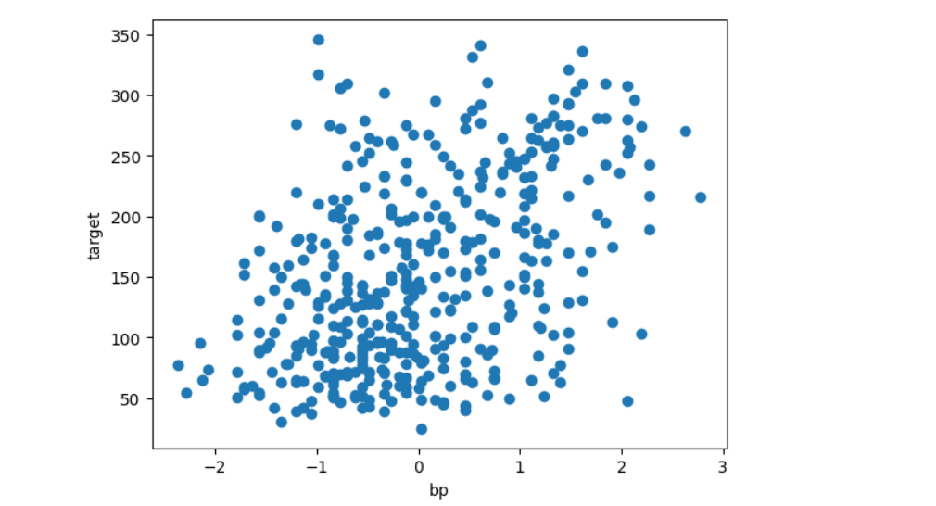

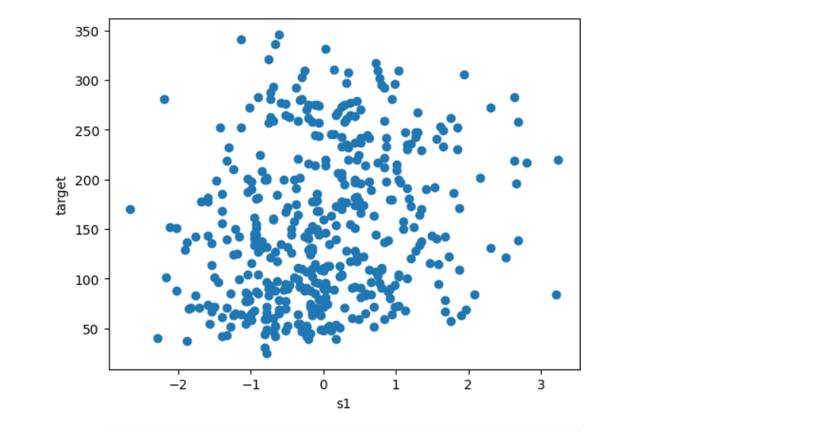

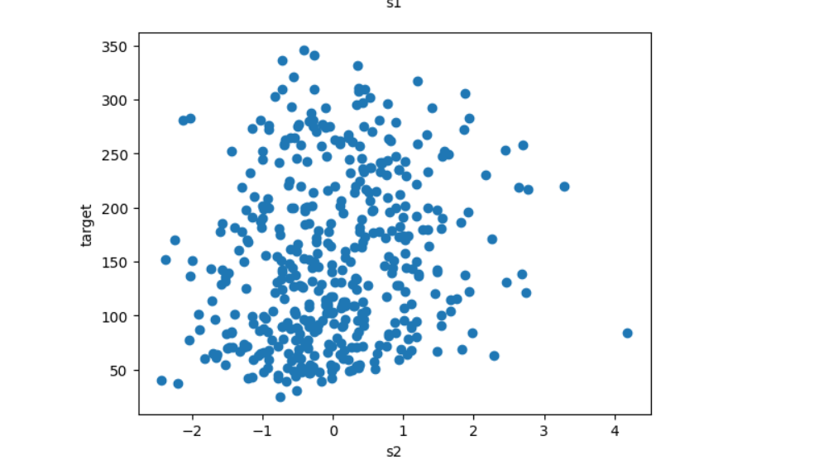

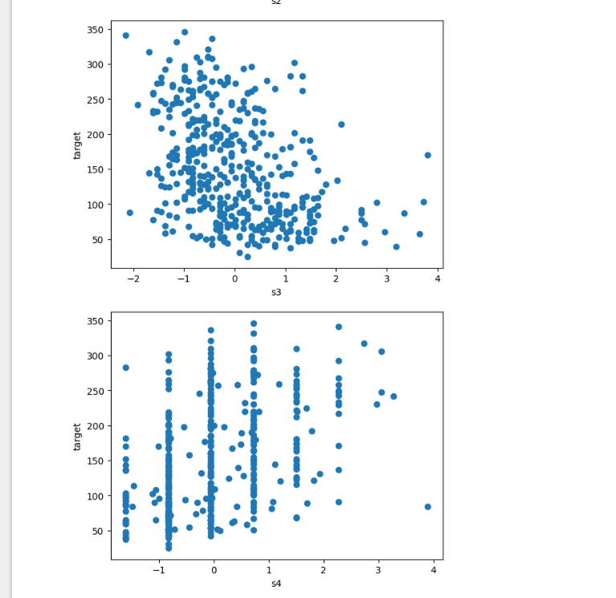

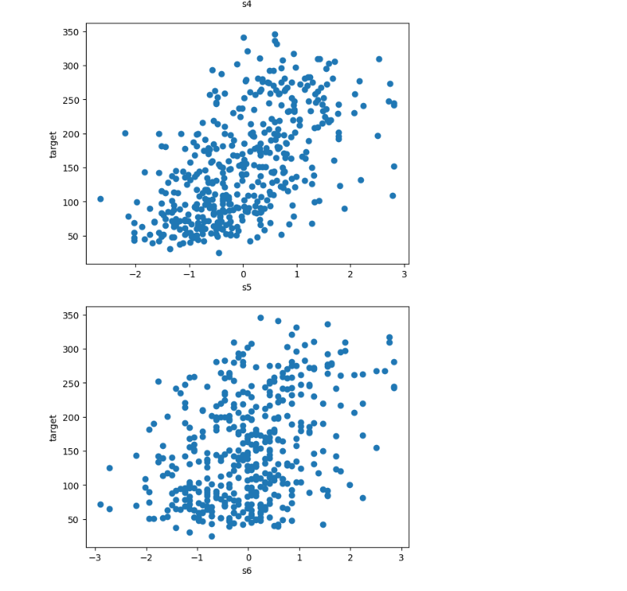

**3.Building the ANN Model (4 marks)**

* Design a simple ANN architecture with at least one hidden layer.
* Use appropriate activation functions .

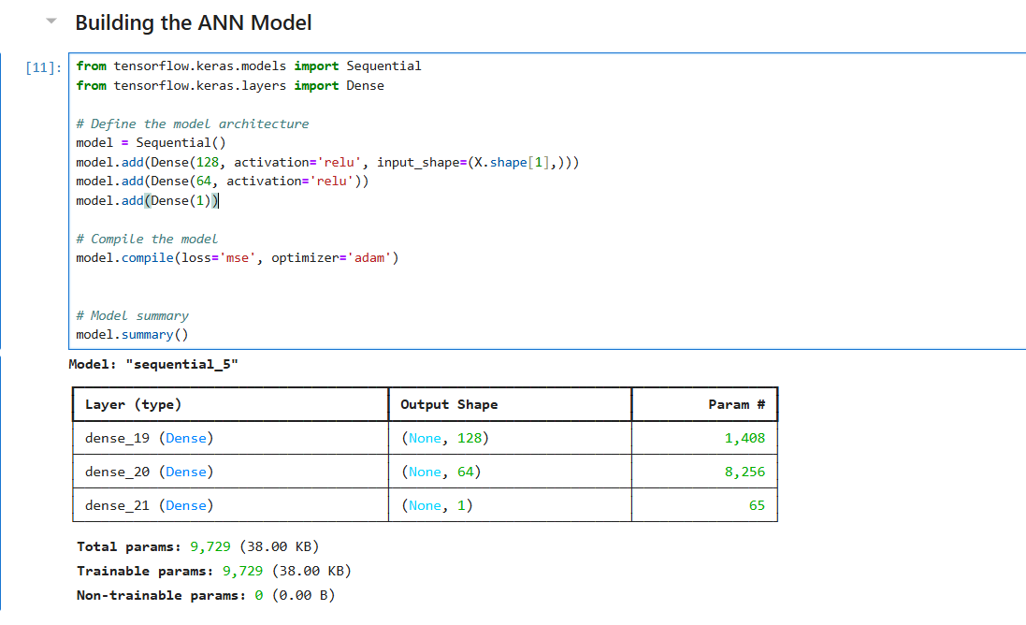

**4.Training the ANN Model (4 marks)**

* Split the dataset into training and testing sets.
* Train the model on the training data.
* Use an appropriate loss function and optimizer

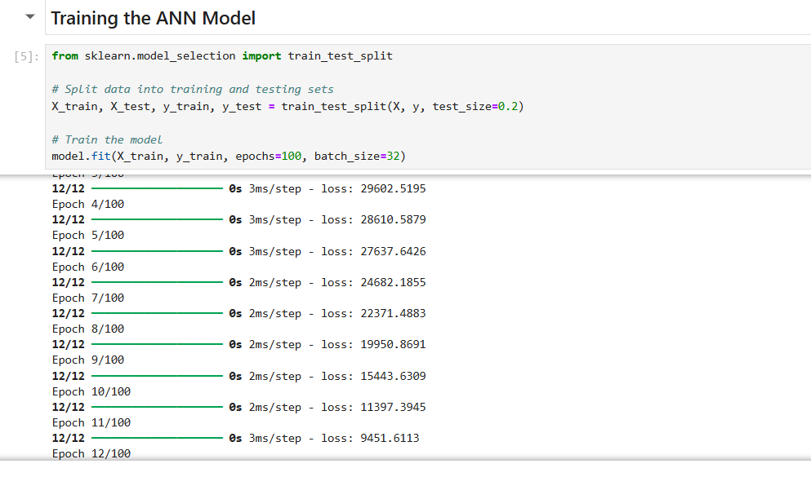.

**5.Evaluating the Model (3 marks)**

* Evaluate the model on the testing data.
* Report the performance metrics (e.g., Mean Squared Error, R² Score).

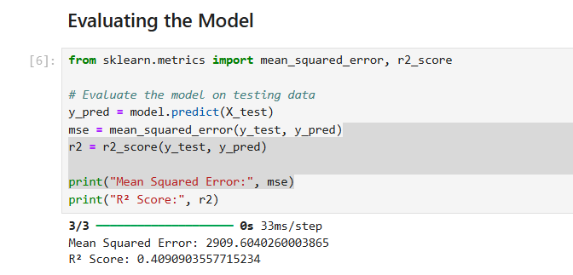

**6.Improving the Model (5 marks)**

* Experiment with different architectures, activation functions, or hyperparameters to improve the model performance.
* Report the changes made and the corresponding improvement in performance.

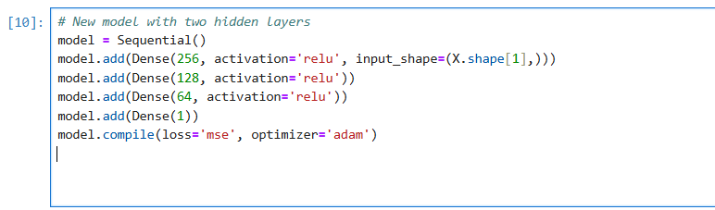

**7.Timely Submission (1 mark)**

**Submission Guidelines:**

* Provide your code in a Jupyter Notebook format and submit the GitHub link here.
* Ensure your explanations and answers are clear and concise.